Darnell Chen  
Lab 2 Report  
ECE 2031 L02  
05 February 2025

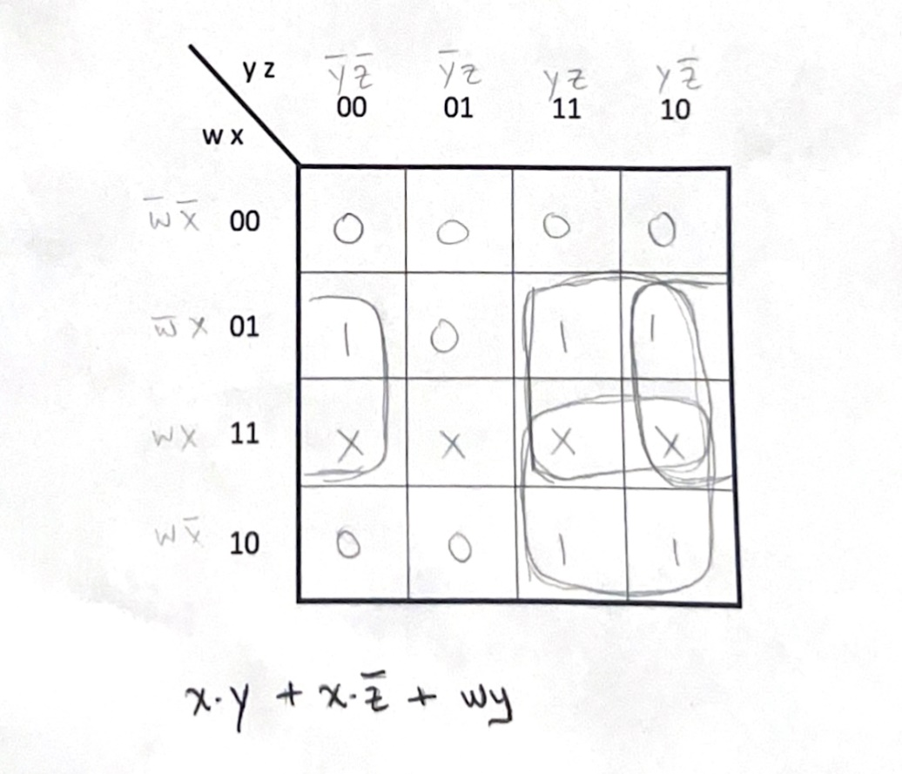

**Figure 1.** Solving for a 4-input KMAP which results in the non-canonical SOP expression   
X·Y + X·/Z + W·Y.

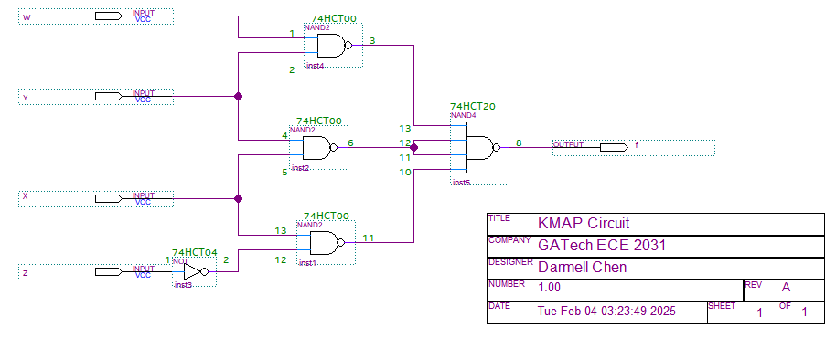

**Figure 2.** A 4-input circuit schematic that represents the logic equation f = X·Y + X·/Z + W·Y.

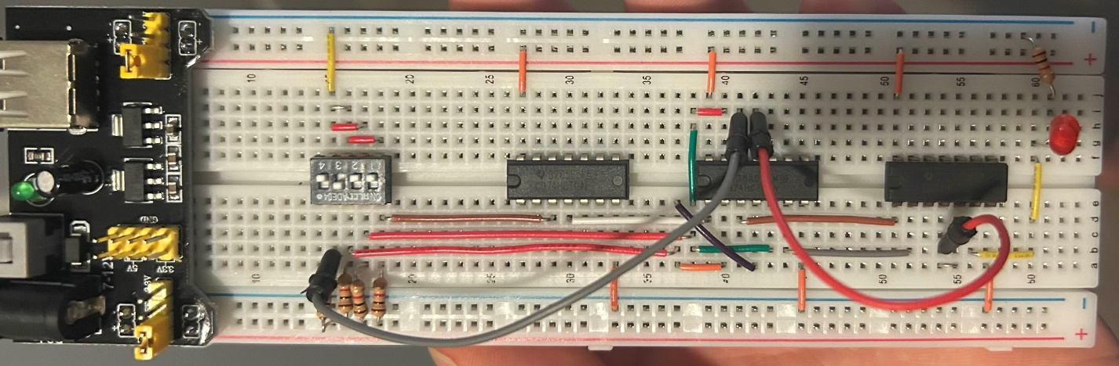

**Figure 3.** A breadboard circuit that uses a 4-input switch and 3 HCT chips in order to create logical outputs that lights up an LED.

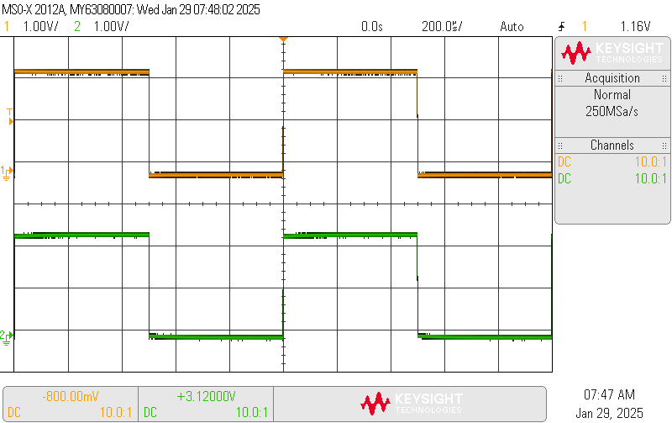

**Figure 4.** Oscilloscope capture of a square wave on top (channel 1, orange) and a square wave on the bottom (channel 2, green). The signals are generated by attaching both channel’s probes to the oscilloscope’s test point.